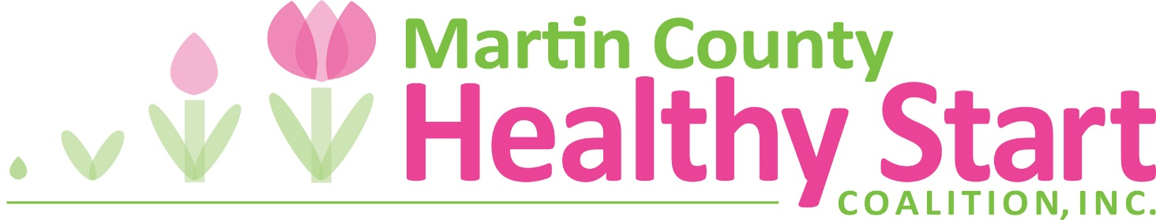

MARTIN COUNTY HEALTHY START COALITION

MEMBERSHIP FORM
Martin County Healthy Start Coalition, Inc. is a 501c3 organization operating under a Board of Directors. The mission of Martin County Healthy Start is to ensure that all babies in Martin County are born healthy. The Coalition relies on members from the community to help set priorities to meet local needs in maternal and infant health.

Name: _________________________________________ Title: ___________________________
Organization (if applicable): _________________________________________________________
Mailing Address: __________________________________________________________________
City: _______________________________________State: ________Zip: ____________________
Phone _____________________________________ Fax__________________________________
E-mail___________________________________________________________________________
If you are representing an agency, please provide its mission:
________________________________________________________________________________
________________________________________________________________________________

I am interested in supporting the Coalition in the following areas:
- Participating in special Coalition activities; health fairs, educational events, presentations
- Serving on a Healthy Start speaker’s bureau
- Attending Coalition planning meetings
- Other______________________________
Please list any other membership or board affiliations:
________________________________________________________________________________
________________________________________________________________________________

- I am the designated voting member of the Martin County Healthy Start Coalition, Inc. representing my agency.
Signature __________________________________________ Date ________________________
MARTIN COUNTY HEALTHY START COALITION

STATEMENT OF MEMBERSHIP DESIGNATION FOR VOTING MEMBER

This is to certify that____________________________________________________________
Name

has been designated to represent__________________________________________________
Agency, Business or Organization

as a designated voting member of the Martin County Healthy Start Coalition, Inc.

______________________________________________________________________________
Signature of Chief Executive Officer or Executive Director

______________________________________________________________________________
Print or Type Name and Title

___________________________________________ __________________________
Address Phone

___________________________________________ __________________________
City, State, Zip Fax #

